Spatial Analysis of Confirmed COVID-19 Cases in Mainland China Post-Wuhan Travel Quarantine

By: Christian Geofroy, Gloria Lim, Ziran Zhou

**I. Research Background:** It came to the attention of the World Health Organization (WHO) that there was a virus outbreak of an unknown cause in Wuhan City, Hubei Province, China in December 2019, which led to a city-wide quarantine on the 23rd of January [1]. The earliest reported infected individuals showed symptoms as early as December 8th, where its origin was traced to the Wuhan South China Seafood Market [1]. This viral outbreak quickly became an international concern and was identified as a new coronavirus. Coronaviruses belong to a large family of viruses which causes a relatively less-severe disease such as the common cold, compared to severe diseases such as MERS and SARS [2]. It was confirmed that the virus was spreading through human-to-human transmission [3]. Historical spatio-temporal data in epidemiology can provide insight and increase our understanding of relationships between environment and health, including factors such as demographic, environmental, behavioral, socioeconomic, genetic, and infectious risk factors [4].

**II. Research Objective:** The goal of this research is to explore the spatial-temporal distribution of the confirmed coronavirus cases. The effectiveness of the travel quarantine in Wuhan will be studied, as well as its eventual impact on the spread of the virus to other provinces in Mainland China [5].

**III. Methodology:** The data used in this analysis will be obtained from the 2019 Novel Coronavirus COVID-19 (2019-nCoV) Data Repository by Johns Hopkins CSSE. The distribution pattern and the spatiotemporal correlation between place and density of confirmed cases will be examined using Hot Spot Analysis (Getis-Ord Gi*). The results will be visualized in a heatmap animation over time in order to assess the effectiveness of current quarantine measures. Additional city demographic data such as age and location of healthcare services will be observed as additional contextual information.

**IV. Expected Results & Significance:** The findings of this study will help identify the association between a travel quarantine implementation and the resulting rate of coronavirus transmission, which will provide insight as to whether the quarantine was an effective precaution.

**V. Tentative Timeline**

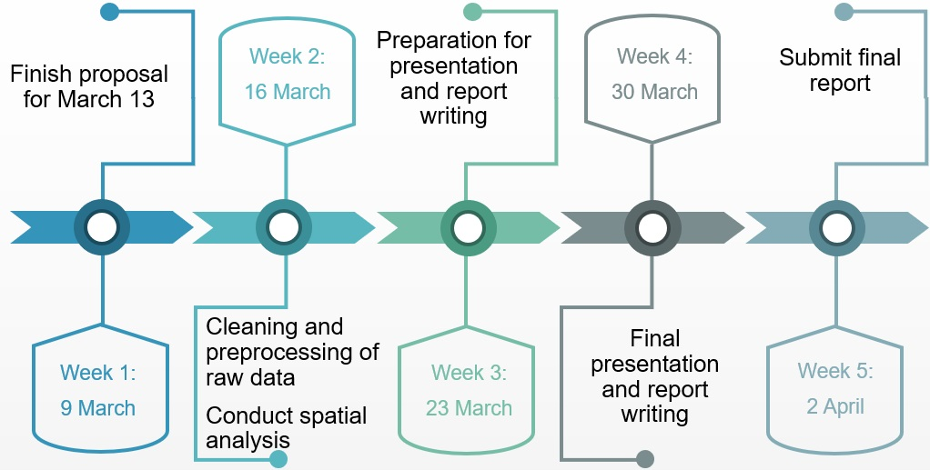

**VI. References**

[1] ncov – CSSE. (2020). Systems.jhu.edu. Retrieved 9 March 2020, from <https://systems.jhu.edu/research/public-health/ncov/>

[2] WHO Statement Regarding Cluster of Pneumonia Cases in Wuhan, China. (2020). Who.int. Retrieved 9 March 2020, from <https://www.who.int/china/news/detail/09-01-2020-who-statement-regarding-cluster-of-pneumonia-cases-in-wuhan-china>

[3] WHO eyes possible sustained nCoV spread in China. (2020). CIDRAP. Retrieved 9 March 2020, from <http://www.cidrap.umn.edu/news-perspective/2020/01/who-eyes-possible-sustained-ncov-spread-china>

[4] Elliott, P., & Wartenberg, D. (2004). Spatial epidemiology: current approaches and future challenges. Environmental health perspectives, 112(9), 998–1006. <https://doi.org/10.1289/ehp.6735>

[5] Chinese Authorities Begin Quarantine of Wuhan City as Coronavirus Cases Multiply. (2020) NPR. Retrieved 12 March, 2020, from <https://www.npr.org/2020/01/23/798789671/chinese-authorities-begin-quarantine-of-wuhan-city-as-coronavirus-cases-multiply>